SELECT product.id, product.name, category.name AS 'category'

FROM product LEFT JOIN category

ON category_id = category.id;

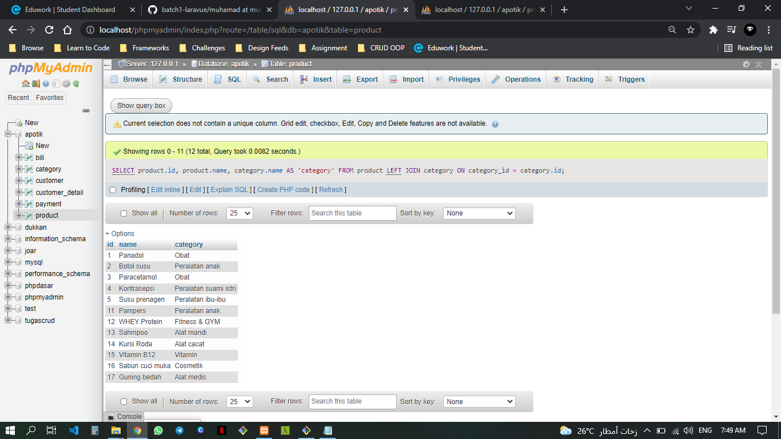

SELECT customer_detail.id, email, instagram, name AS "owner"

FROM customer_detail LEFT JOIN customer

ON customer_id = customer.id;

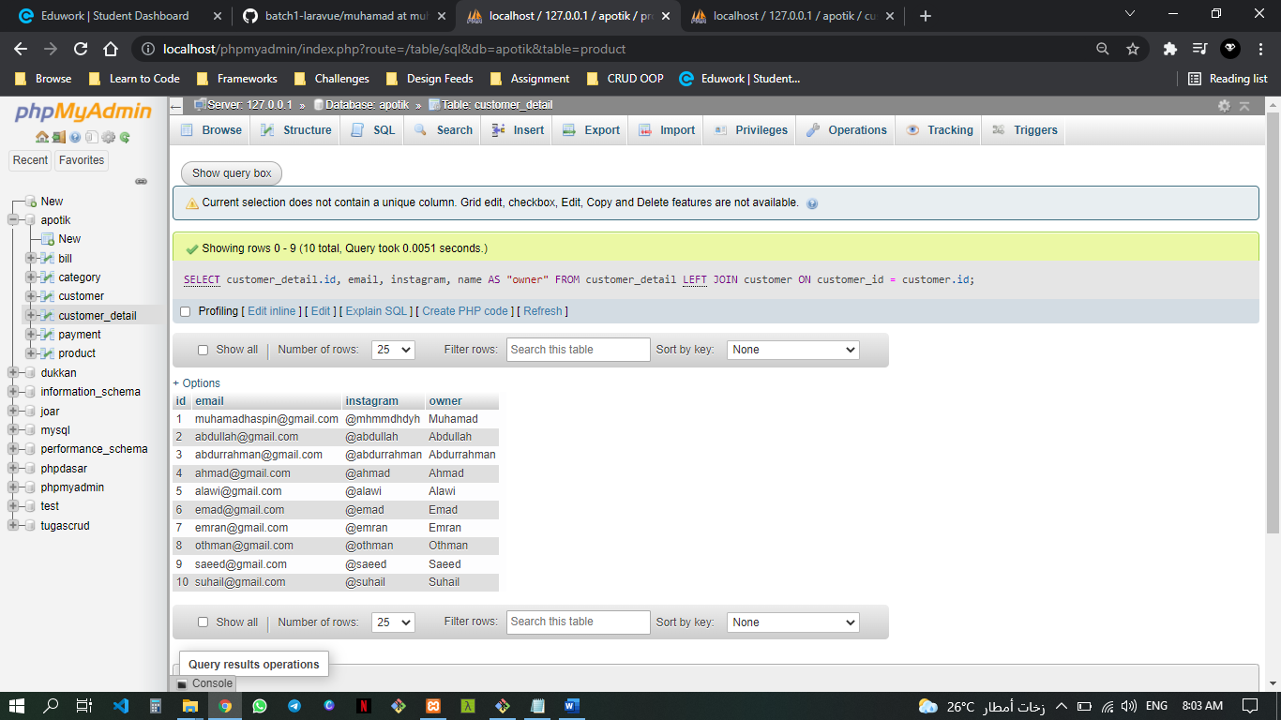

SELECT customer.id, customer.name AS 'customer', pay_date, total_price

FROM payment RIGHT JOIN customer

ON customer_id = customer.id;

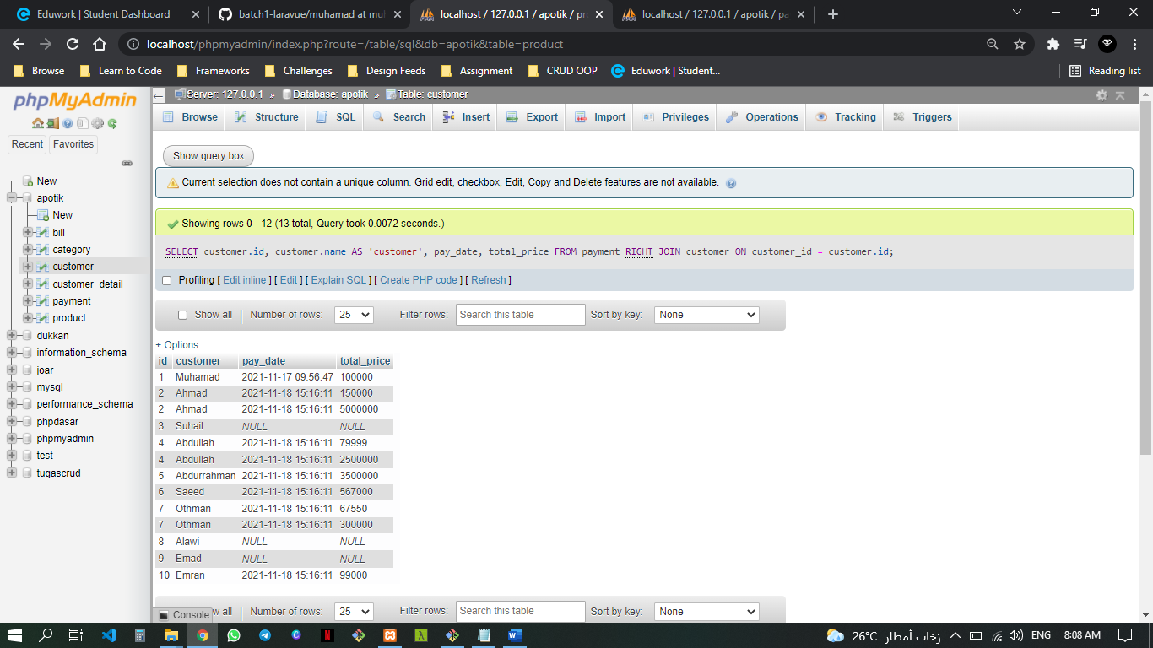

SELECT customer.name AS 'user', instagram

FROM customer_detail RIGHT JOIN customer

ON customer_id = customer.id;

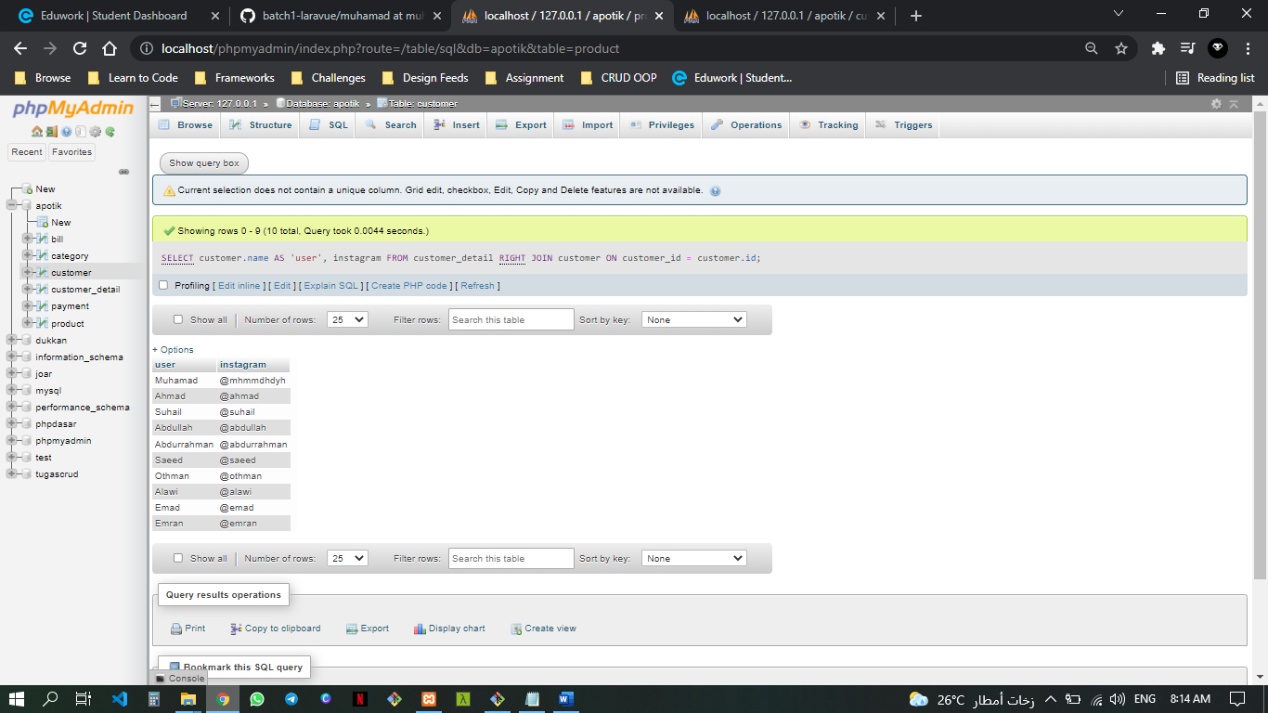

SELECT category.name AS 'category', product.name, price

FROM product LEFT JOIN category

ON category_id = category.id

WHERE product.name LIKE '%pa%'

ORDER BY category.name ASC;

